**Control Flow:** The order in which computer programs execute a set of instructions is known as

**Control Structures:** Used to change what instructions are executed based on defined **conditions**

**If Statements:**

- Conditional statements are one of the most common control structures in programming. Allow us to specify code that runs only if a condition is true or false

**Parentheses:** We place the Boolean expression that the if statement is evaluating in parentheses ().

**Braces:** After the Boolean expression, we write a set of braces {}. Write the code that will execute if the Boolean expression evaluates to true inside these braces.

**Indentation:** While whitespace won’t impact our program, it is convention to indent the code inside the braces by two spaces.

**Else Statements:**

- An else clause can be added to an if statement to provide code that will only be executed if the if condition is false.

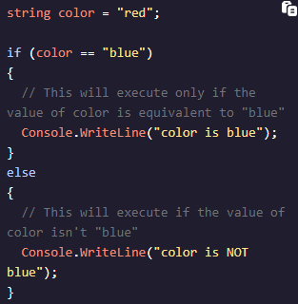

**Else/If Statements:**

- We can chain conditional statements by combining if and else statements into else if (put all into parenthesis)   
- Checks additional conditions and chains them together  
- Can add an optional else block at the end to catch cases that do not match any of the conditions

**Do/While Statements:**

- Executes a block of code at least once and then repeatedly executes the block as long as a specified condition evaluates to true.

**Int.Parse:**- Converts a string representation of a number into its 32-bit signed integer equivalent.   
- Used when you need to convert user input (often in the form of a string) into an integer for further processing.  
- String must represent a valid integer or it will throw an exception

**Switch Statements:**

- A shorter syntax for a series of conditional statements based on a single expression.  
- Execute a code block from a list of case conditions for which the expression validates as true.  
- Cases will check for equality when no Boolean operator is provided, such as with case 25.

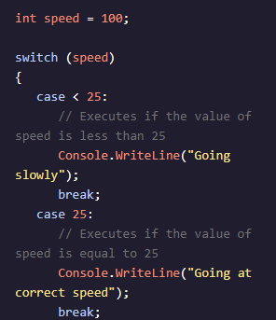

- The cases are evaluated in the order they are defined. When a case **matches** with the switch expression, the code block for that case is executed. When a case does not match the switch expression, the program moves on to the next case.  
- The code inside the default case will only run if no other case is met. The default case is optional in a switch statement.

**Ternary Operators:**

- Execute one expression if the condition is true and the second expression otherwise

- The same expression in long-form

